1. **Agenda**:
   1. Going to create Consumer in this lecture.
2. 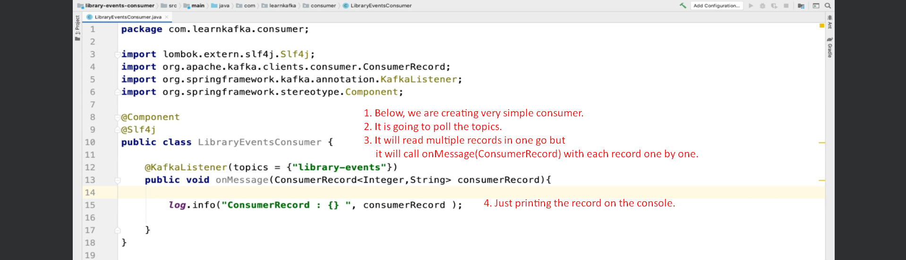
3. 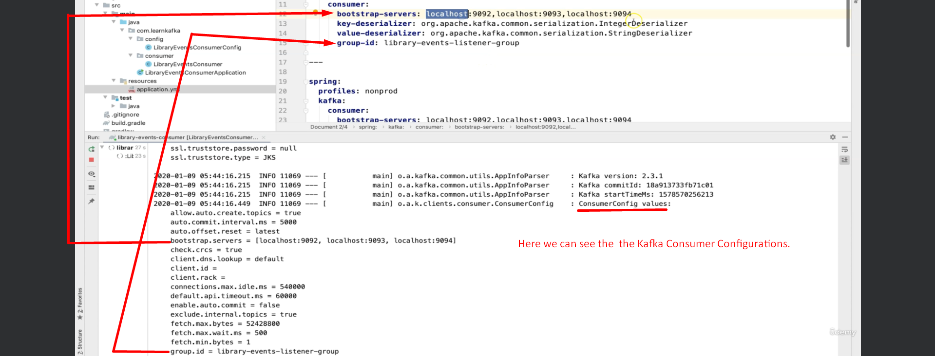  
   
4. Next step is to publish the Kafka Records in to the Kafka Topic.  
   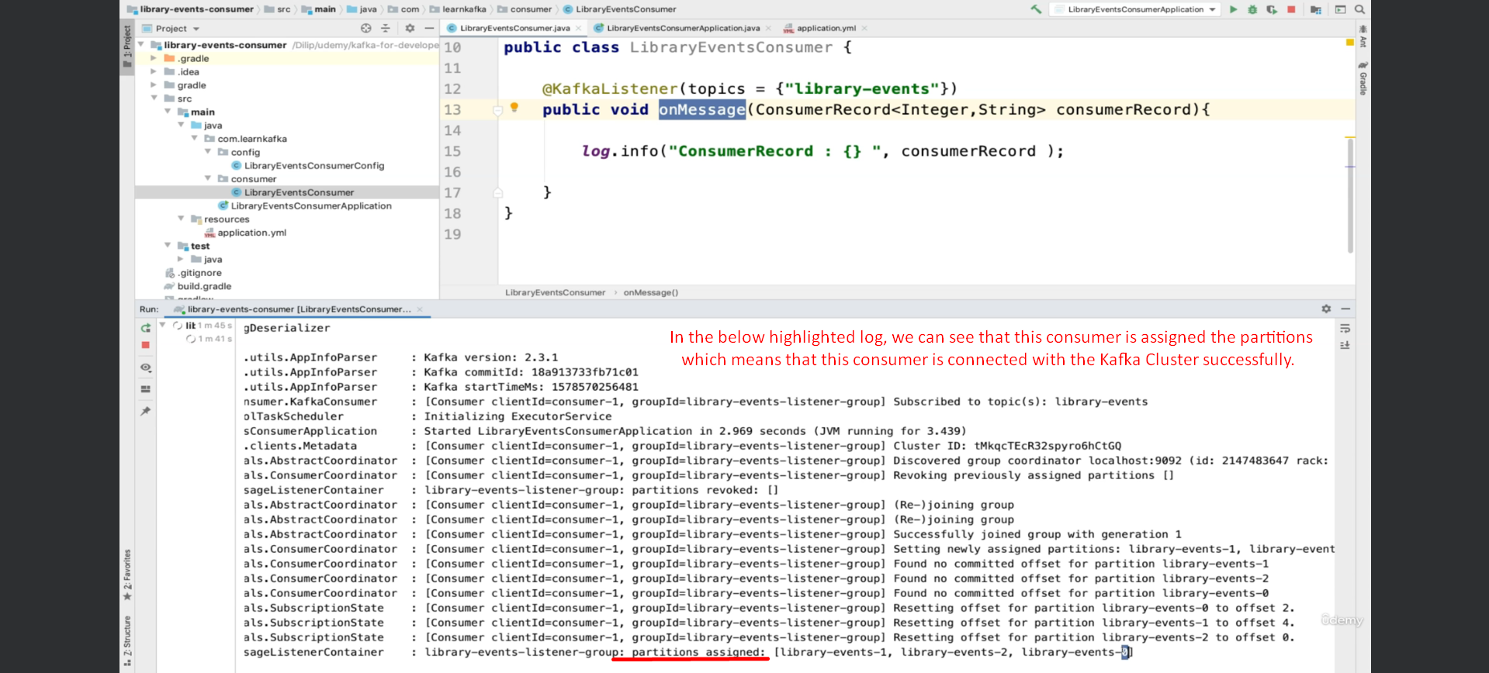
5. Let’s publish a msg.   
   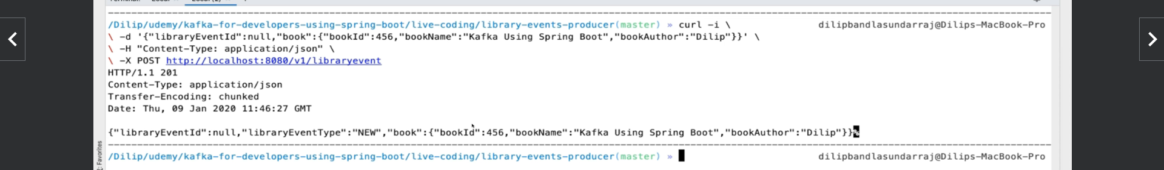
6. Let’s see the msg in consumer side (console)  
     
   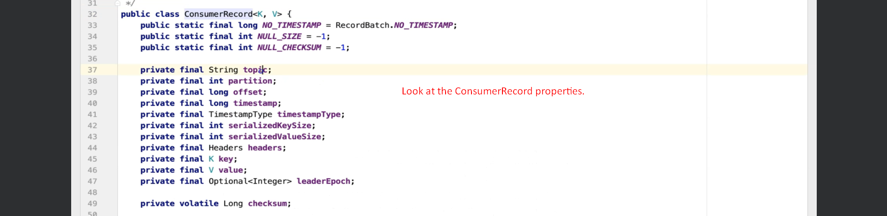
7. NOTE: If you look at the value of headers, it is an array of bytes as in the producer side, we are setting headers’ value as bytes.